Project 4 1001551229

Swetha Vijaya Raghavan

First Name and Last Name must be alphabets. No numericals allowed. Even when it is blank, since I have done html validations, it says Please fill out this filed for the respective fields.

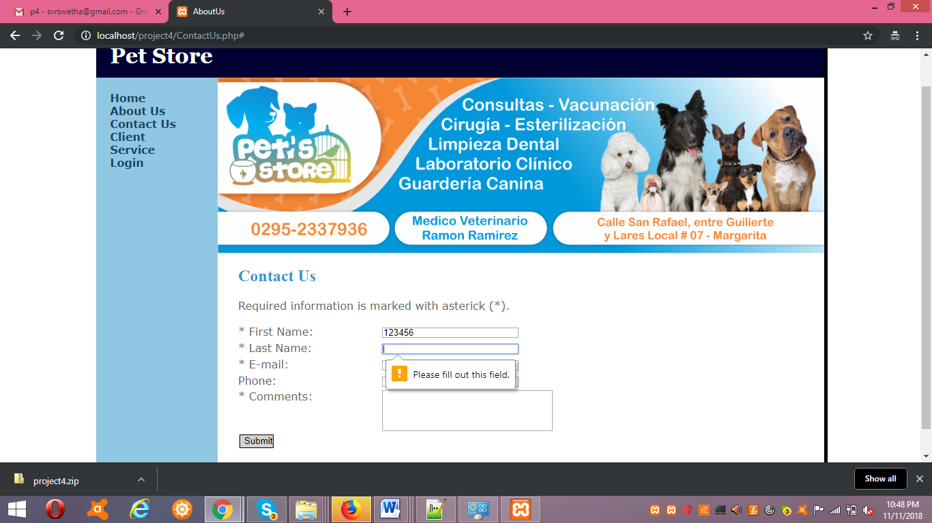

Fig1

In Fig2, these are the values given in the form. When Numericals given in First Name and Last Name, it displays an message in the top of the page saying Alphabets only allowed for First Name; Alphabets only allowed for Last Name; for Phonenumber we need 10 digits and in a specific pattern  
(xxx-xxx-xxxx) mentioned in Fig3. The output is shown in Fig3.

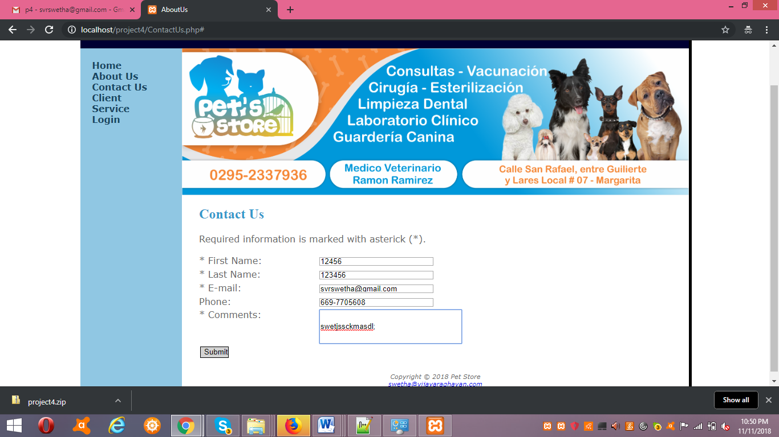

Fig2

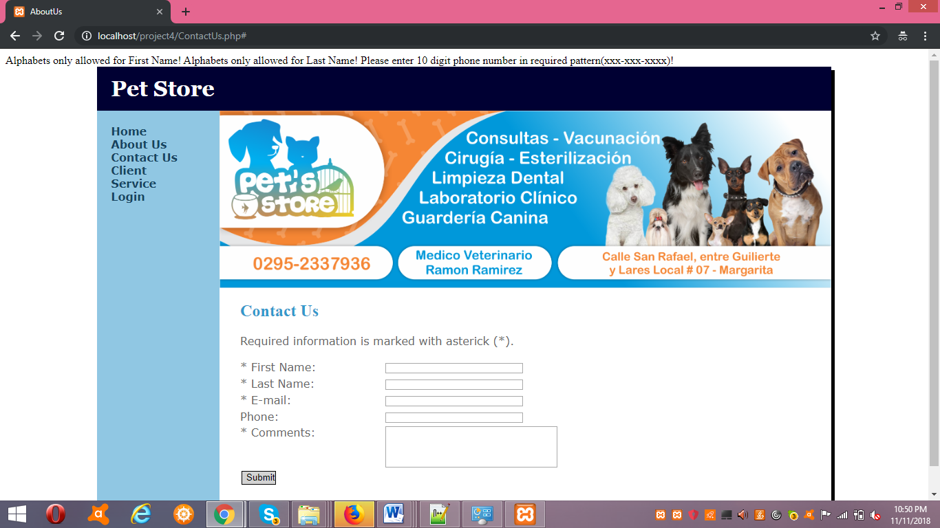

Fig3

Fig4 is the inputted values. For the client page when I enter numbers for First Name, Last Name and invalid email, it displays message in the top of the page saying Alphabets only allowed for First Name; Alphabets only allowed for Last Name; Its not a valid email; output shown in Fig 5.

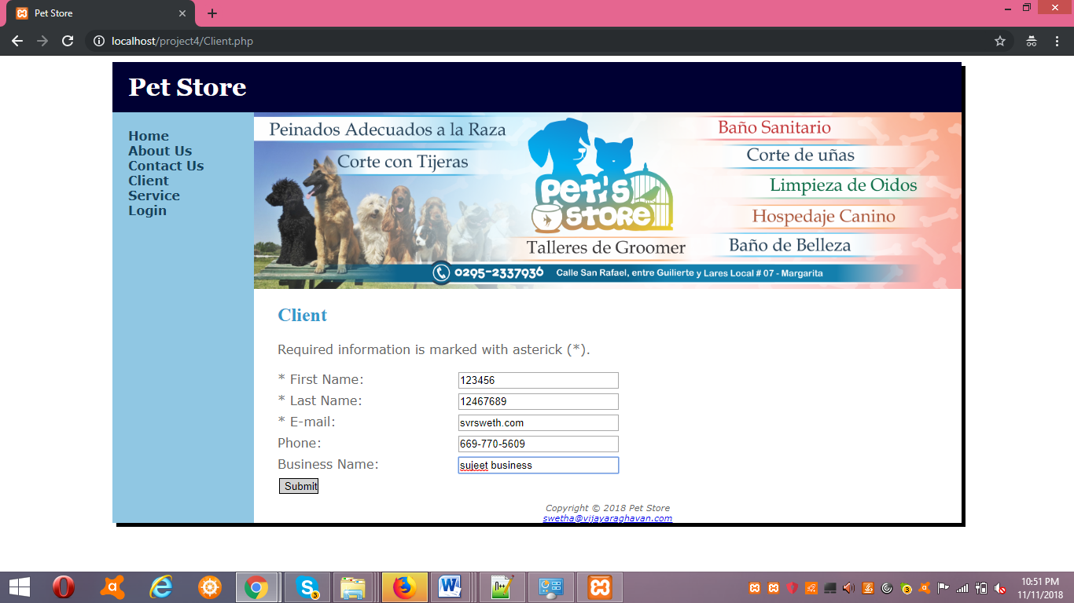

Fig 4

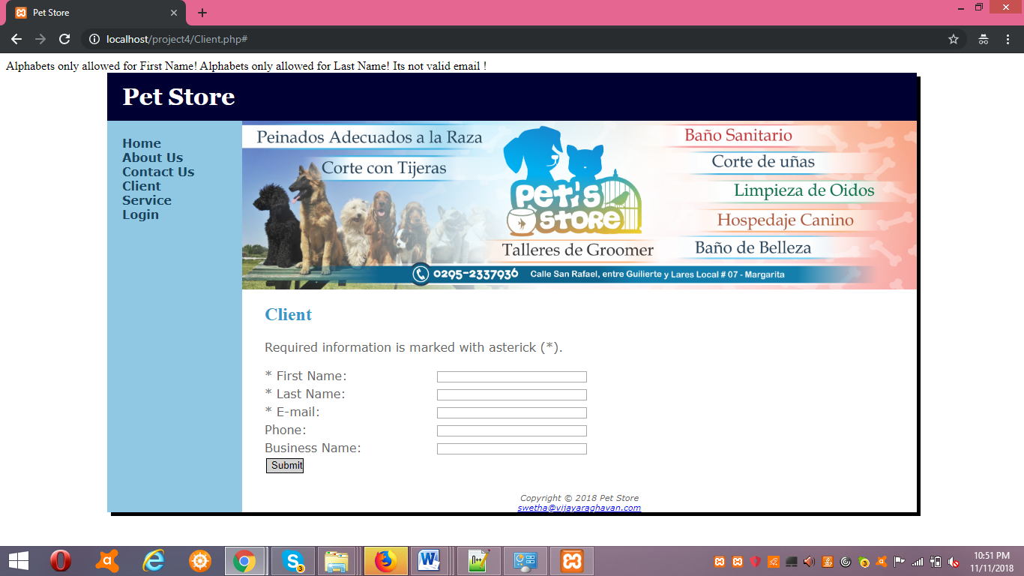

Fig 5

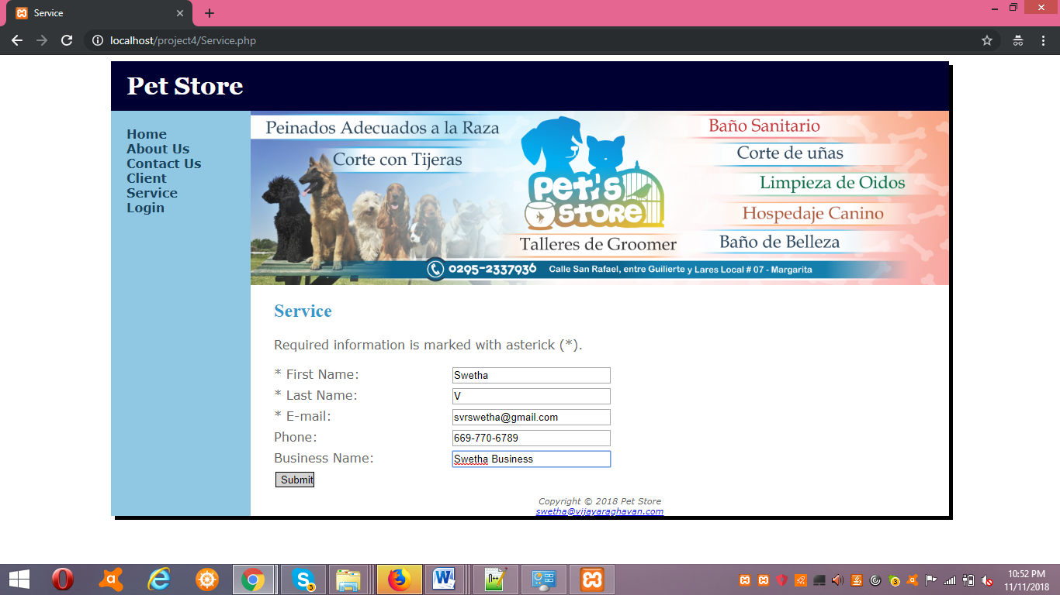

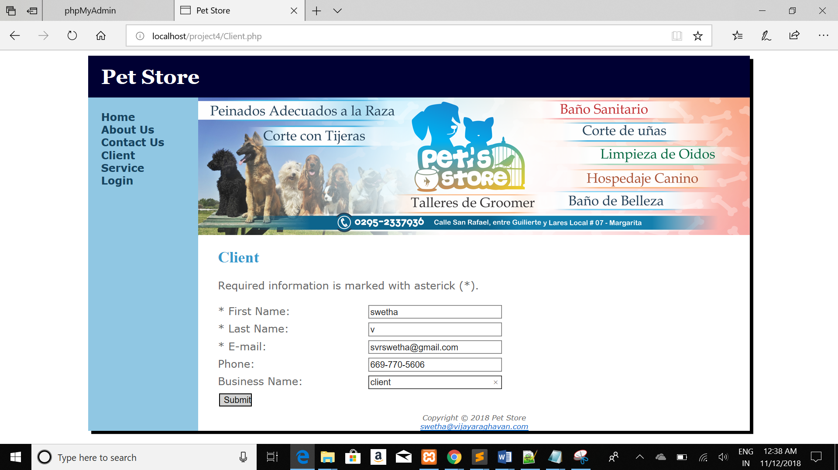

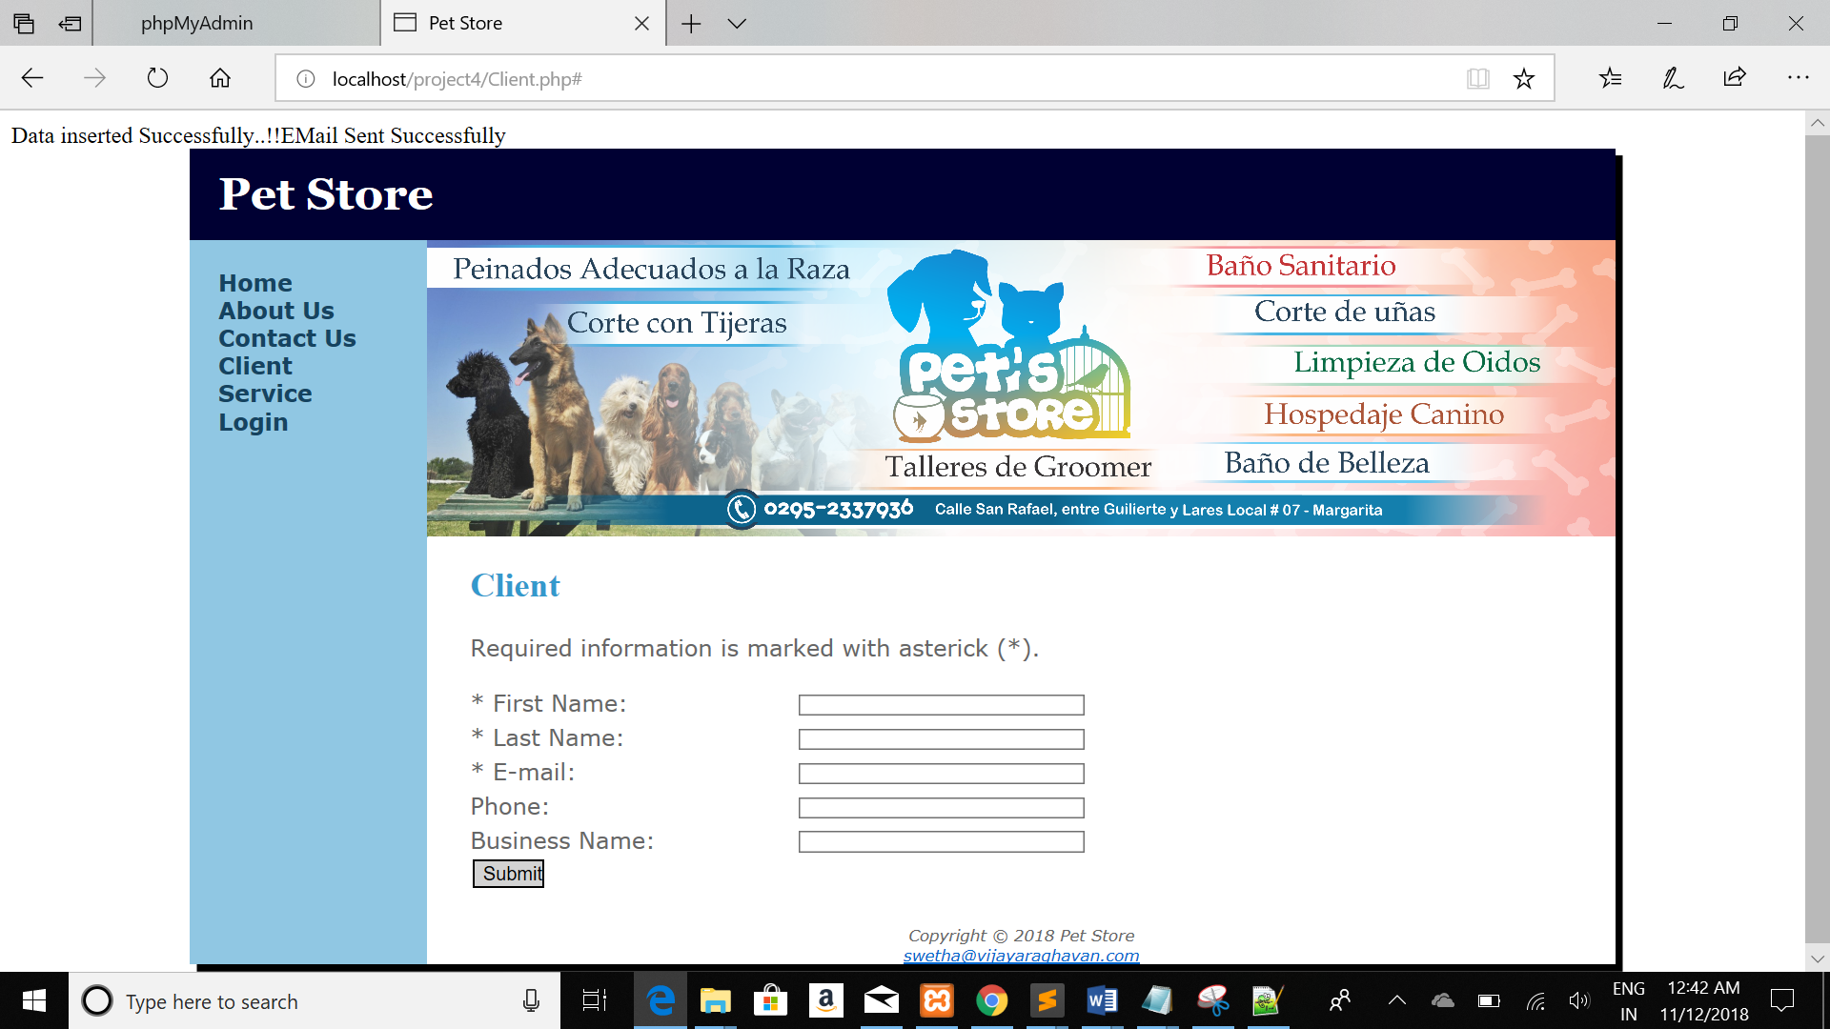

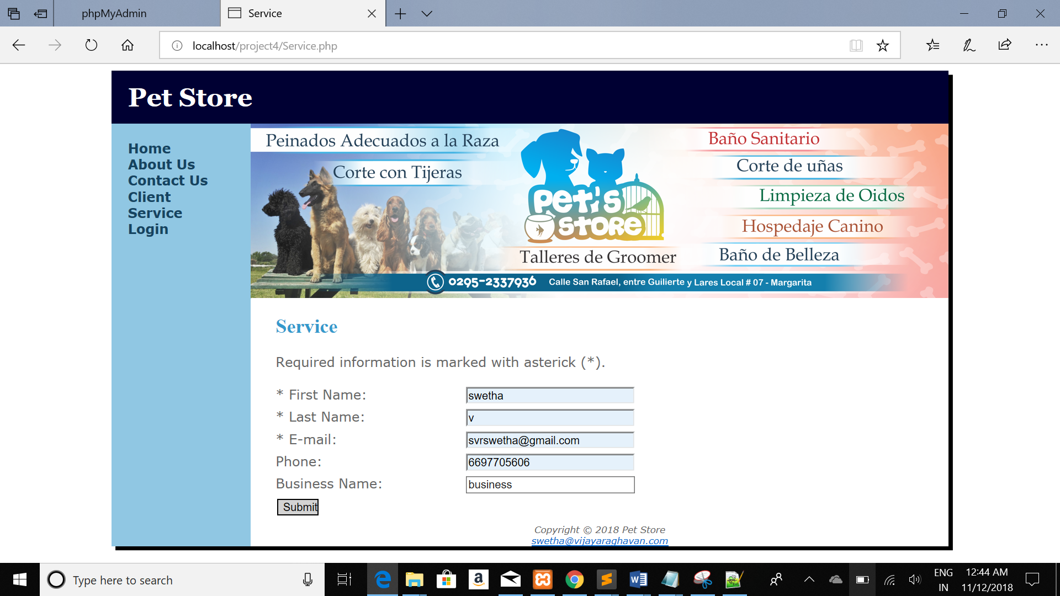

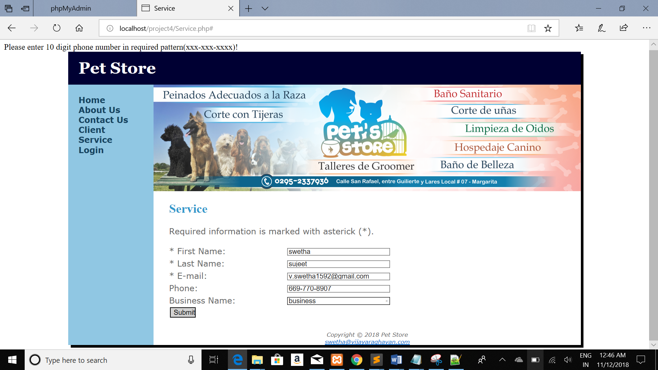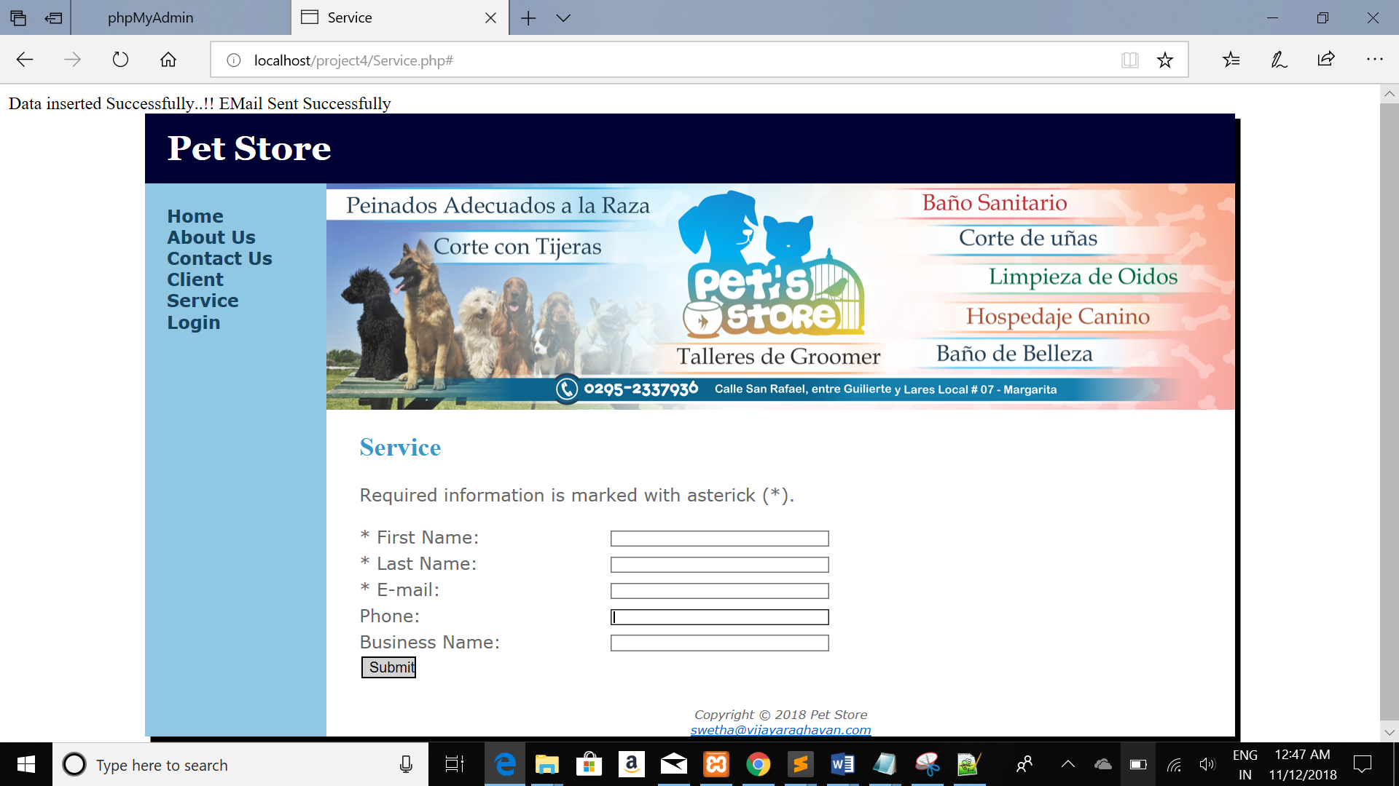

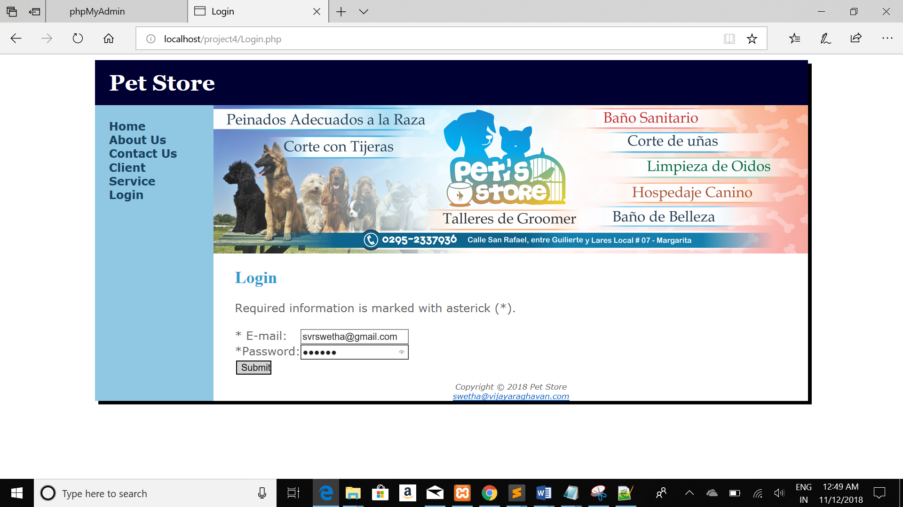

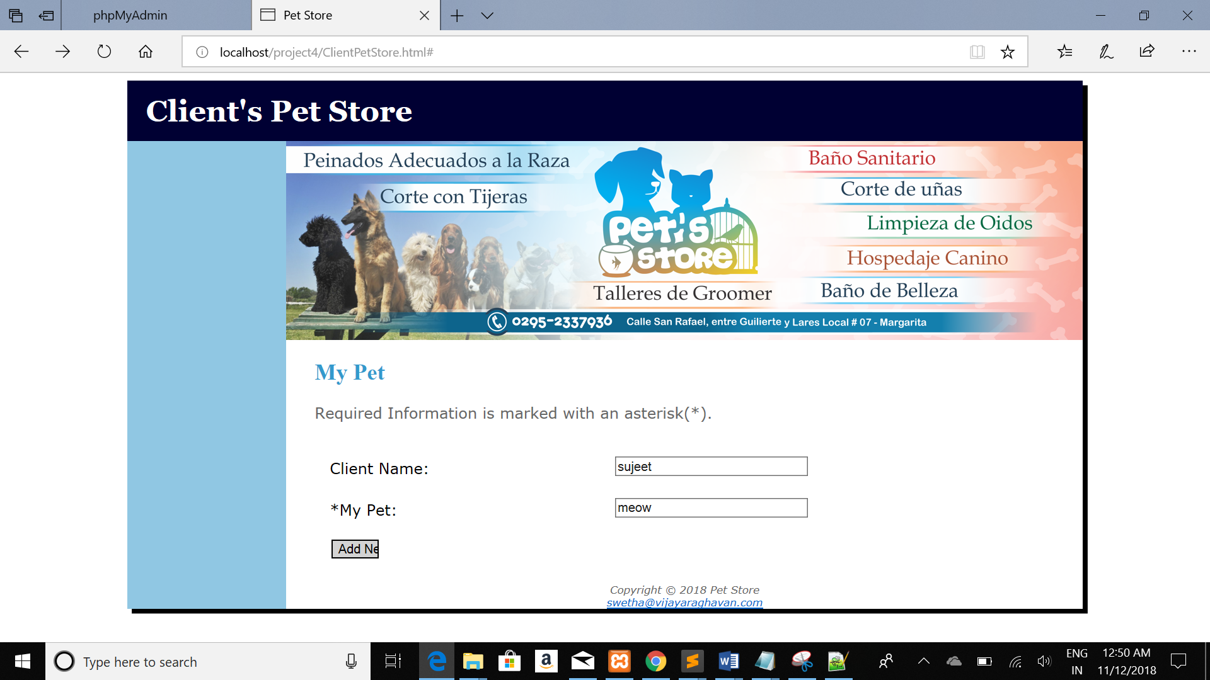

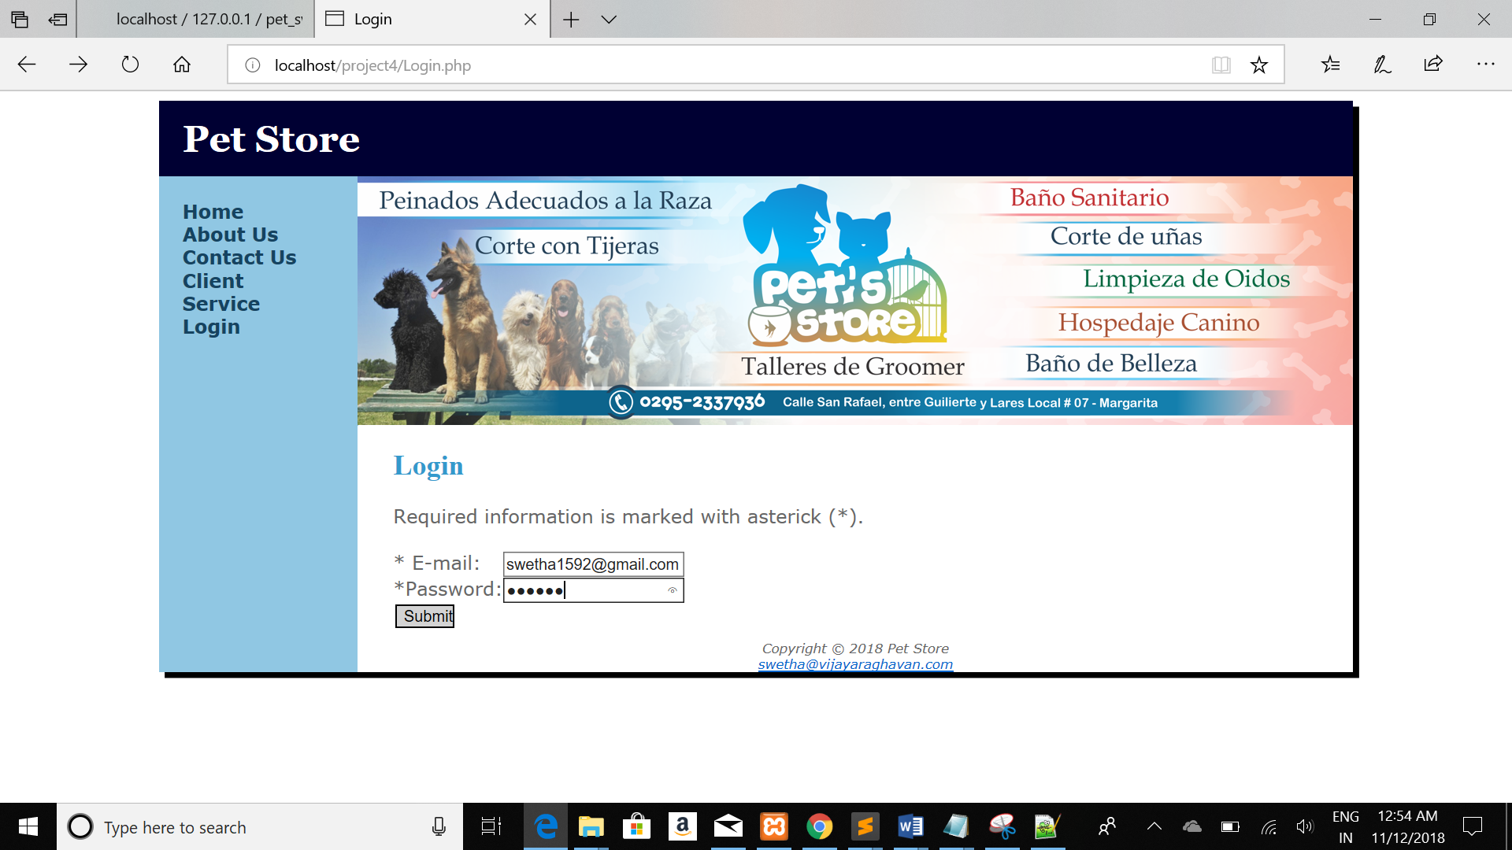



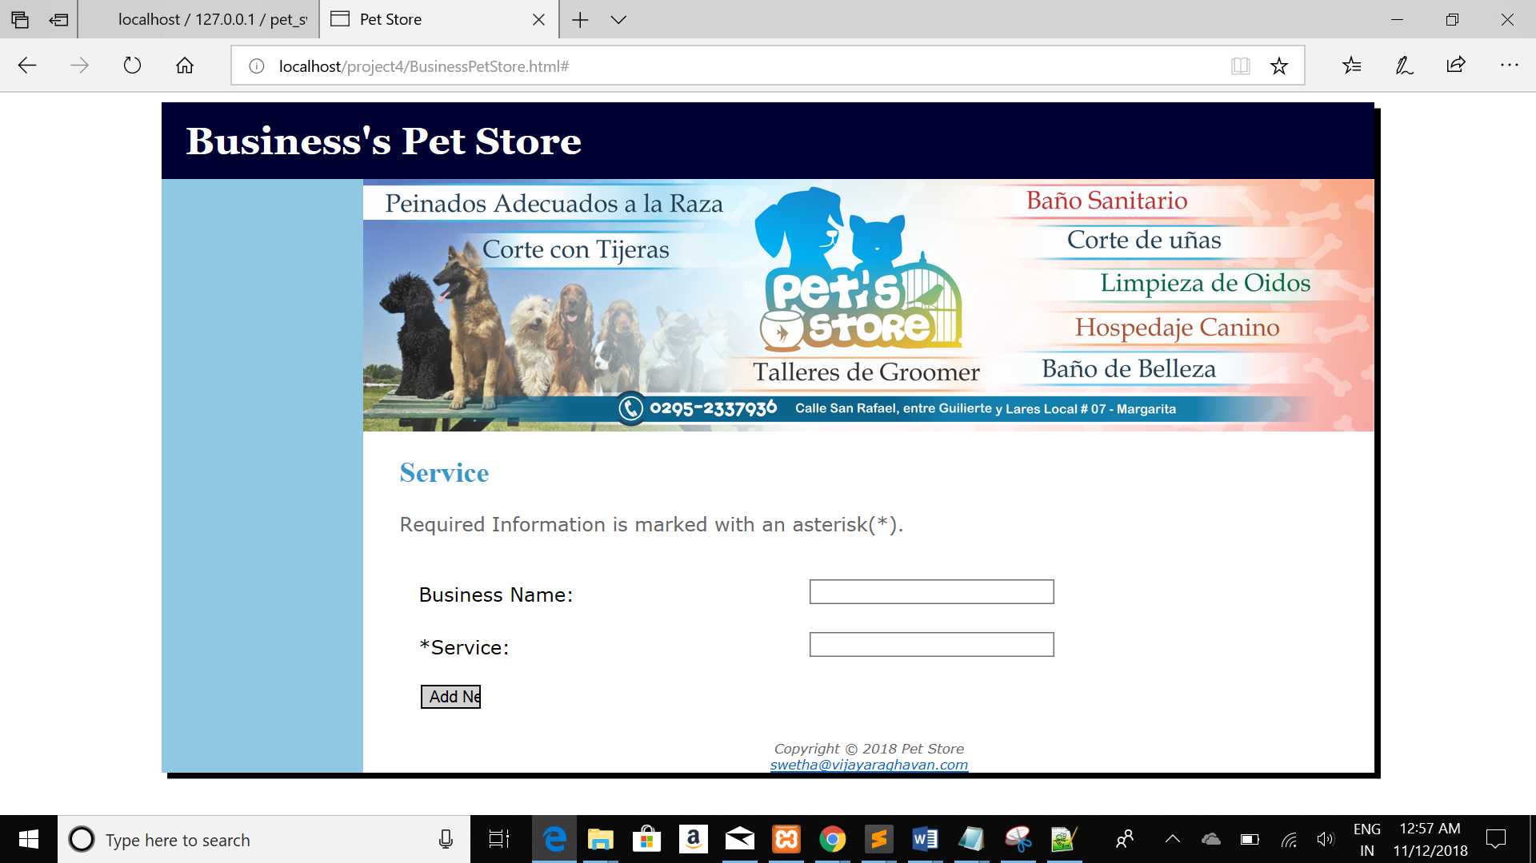

Database Screenshots(dbname: pet_swetha):

I have 5 tables.

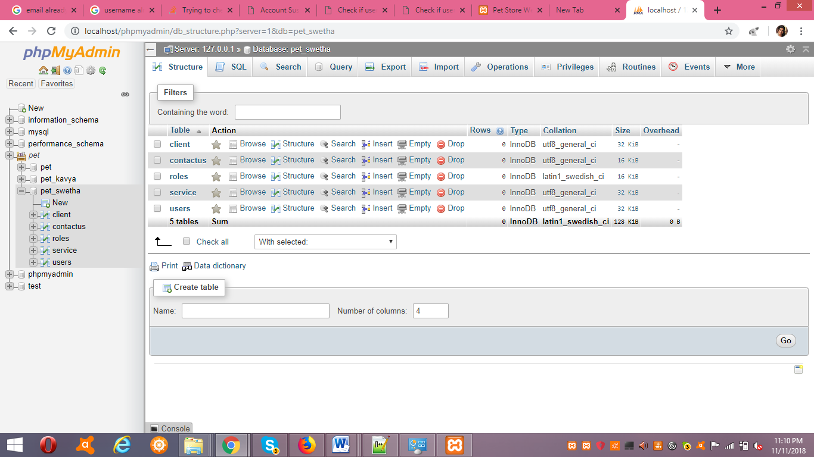

Client table along with filed names and constraints

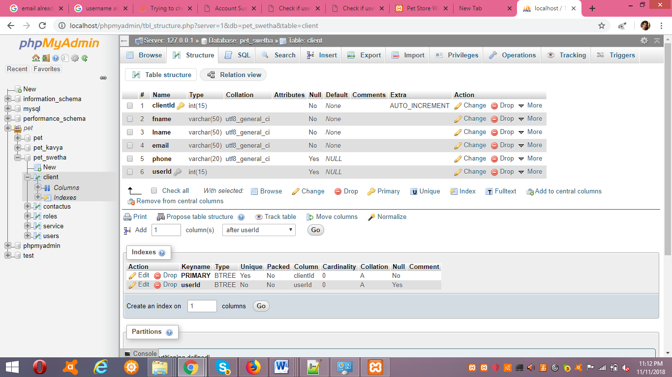

contactus table along with filed names and constraints

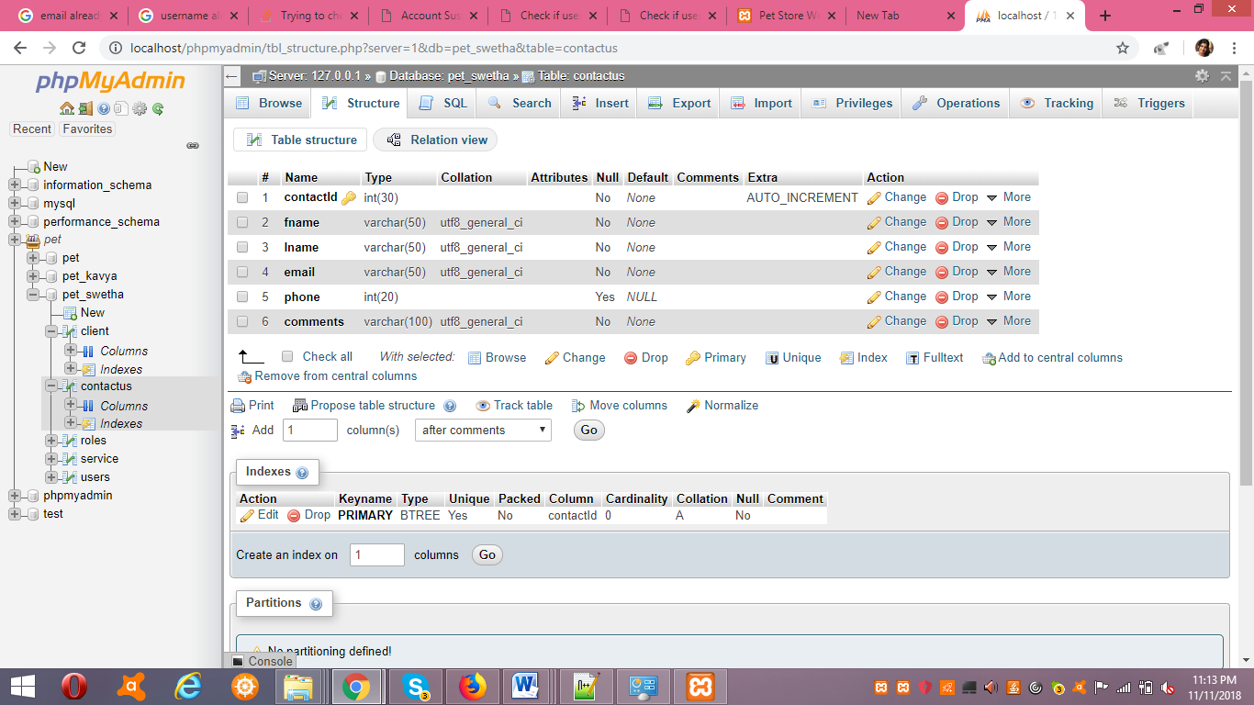

roles table along with filed names and constraints

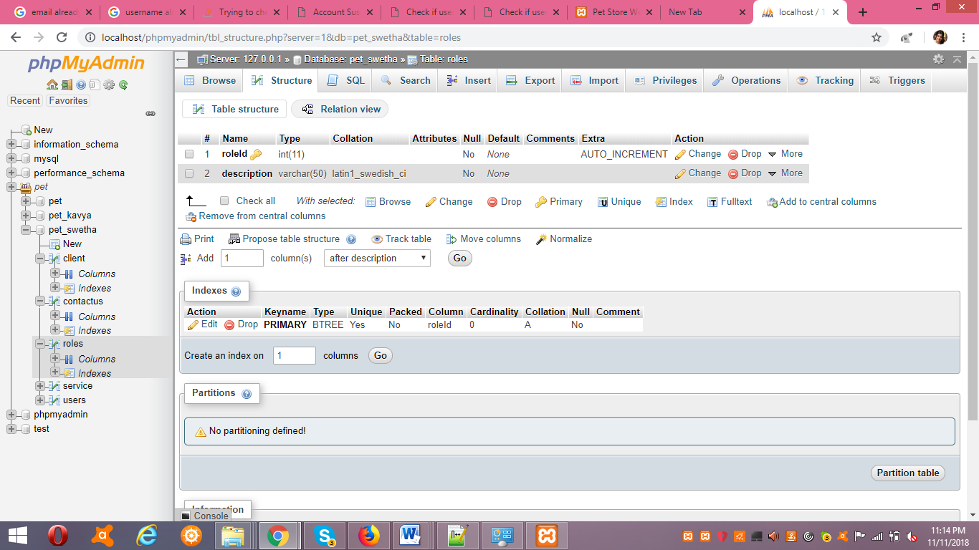

service table along with filed names and constraints

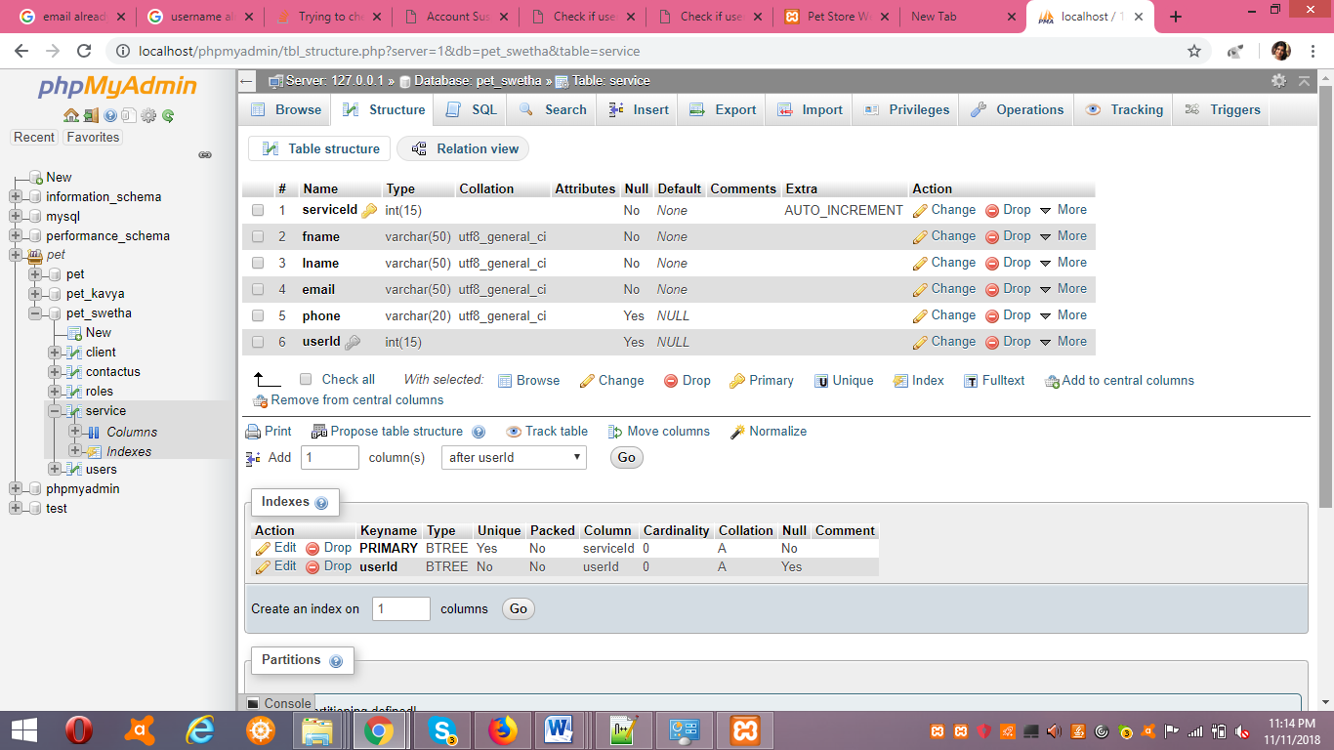

users table along with filed names and constraints

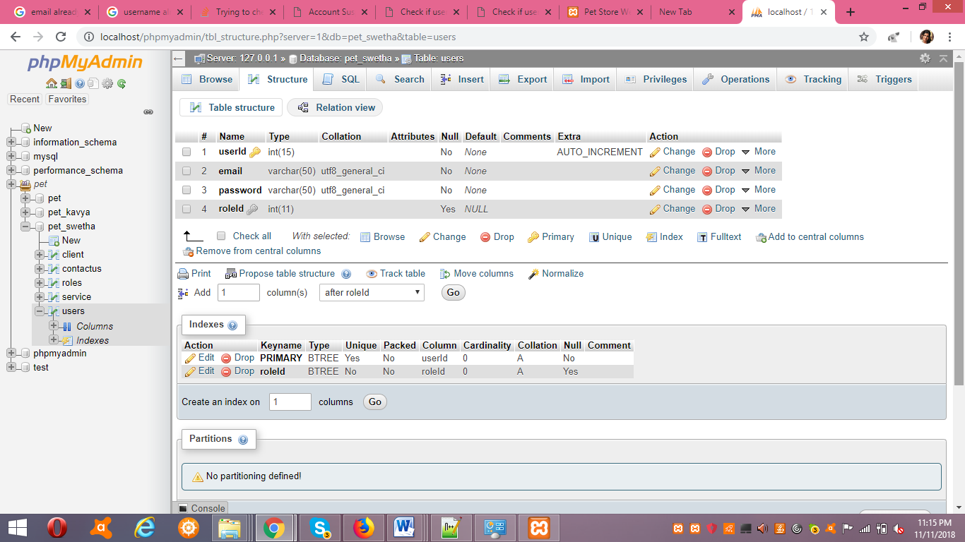

These are the create statements I have used to create tables

CREATE TABLE roles(

roleId int NOT NULL AUTO_INCREMENT,

description varchar(50) NOT NULL,

PRIMARY KEY (roleId)

);

CREATE TABLE Users(

userId int(15) NOT NULL AUTO_INCREMENT,

email varchar(50) NOT NULL,

password varchar(50) NOT NULL,

roleId int ,

PRIMARY KEY (userId),

FOREIGN KEY (roleId) REFERENCES roles(roleId)

)ENGINE=InnoDB DEFAULT CHARSET=utf8;

CREATE TABLE contactUs (

contactId int(30) NOT NULL AUTO_INCREMENT,

fname varchar(50) NOT NULL ,

lname varchar(50) NOT NULL,

email varchar(50) NOT NULL,

phone int(20) DEFAULT NULL,

comments varchar(100) NOT NULL,

PRIMARY KEY (contactId)

)ENGINE=InnoDB DEFAULT CHARSET=utf8;

CREATE TABLE client (

clientId int(15) NOT NULL AUTO_INCREMENT,

fname varchar(50) NOT NULL ,

lname varchar(50) NOT NULL,

email varchar(50) NOT NULL,

phone varchar(20) DEFAULT NULL,

userId int(15),

PRIMARY KEY (clientId),

FOREIGN KEY (userId) REFERENCES Users(userId)

)ENGINE=InnoDB DEFAULT CHARSET=utf8;

CREATE TABLE service (

serviceId int(15) NOT NULL AUTO_INCREMENT,

fname varchar(50) NOT NULL ,

lname varchar(50) NOT NULL,

email varchar(50) NOT NULL,

phone varchar(20) DEFAULT NULL,

userId int(15),

PRIMARY KEY (serviceId),

FOREIGN KEY (userId) REFERENCES Users(userId)

)ENGINE=InnoDB DEFAULT CHARSET=utf8;